**Micro Project Report**

**On**

**Voting System**

**Diploma Computer Engineering**

**Semester 5**

**(MOBILE APPLICATION DEVELOPMENT USING ANDROID-4530703)**

|  |  |  |
| --- | --- | --- |
| **Group Members** | | |
| **Sr. No.** | **Enrollment No.** | **Student Name** |
| **1** | **226090307006** | **CHANPURA KEYUR D.** |
| **2** | **226090307007** | **CHANPURA SHIVAM M.** |
| **3** | **226090307064** | **MAHERIYA HARDIK S.** |

**Guided By: -**

**Mrs. N.J.Rachhadiya**

**Lecturer, CE Department,**

**C. U. Shah Polytechnic, Surendranagar**

**Index**

|  |  |
| --- | --- |
| **Sr. No.** | **Topic Name** |
| **1** | Introduction to the Project. |
| **2** | Hardware and Software requirements (If any) |
| **3** | Sample Code/ Architecture (If any) |
| **4** | Screenshots of System and Output (If any) |
| **5** | Application of your Project |
| **6** | Advantages and Disadvantages of Project |
| **7** | Summary of Project |
| **8** | References |

**C.U.SHAH GOVERNMENT POLYTECHNIC - WADHWAN**

COMPUTER ENGINEERING



**CERTIFICATE**

This is to certify that the Mini Project entitled **“Voting System”** has been carried out by **CHANPURA KEYUR D.** under my guidance in partial fulfillment of the degree of Diploma Engineering in **COMPUTER ENGINEERING** 5th Semester of Gujarat Technological University, Ahmedabad during the academic year 2024

**Guides:**

|  |  |  |
| --- | --- | --- |
| Mrs. N.J.Rachhadiya |  | Mr. K.G.Patel |
| Internal Guide |  | Head of Department |

**C.U.SHAH GOVERNMENT POLYTECHNIC - WADHWAN**

COMPUTER ENGINEERING



**CERTIFICATE**

This is to certify that the Mini Project entitled **“Voting System”** has been carried out by **CHANPURA SHIVAM M.** under my guidance in partial fulfillment of the degree of Diploma Engineering in **COMPUTER ENGINEERING** 5th Semester of Gujarat Technological University, Ahmedabad during the academic year 2024

**Guides:**

|  |  |  |
| --- | --- | --- |
| Mrs. N.J.Rachhadiya |  | Mr. K.G.Patel |
| Internal Guide |  | Head of Department |

**CU.SHAH GOVERNMENT POLYTECHNIC - WADHWAN**

COMPUTER ENGINEERING



**CERTIFICATE**

This is to certify that the Mini Project entitled **” Voting System”** has been carried out by **MAHERIYA HARDIK S.** under my guidance in partial fulfillment of the degree of Diploma Engineering in **COMPUTER ENGINEERING** 5th Semester of Gujarat Technological University, Ahmedabad during the academic year 2024

**Guides:**

|  |  |  |
| --- | --- | --- |
| Mrs. N.J.Rachhadiya |  | Mr. K.G.Patel |
| Internal Guide |  | Head of Department |

**Introduction to Project**

* In an era where technology plays a pivotal role in our daily lives, traditional voting methods are increasingly being challenged by the demand for more efficient, accessible, and secure electoral processes. This project focuses on creating an Android-based voting system designed to enhance the voting experience for users, enabling them to participate in elections conveniently from their mobile devices.
* The primary goal of this project is to develop a user-friendly application that simplifies the voting process while maintaining the highest standards of security and integrity. By leveraging mobile technology, we aim to increase voter participation, streamline the electoral process, and provide real-time results, thus fostering transparency and trust in democratic practices.
* The application will feature essential functionalities, including user registration, candidate selection, and secure vote casting for managing elections. This system not only addresses the challenges of traditional voting but also positions itself as a modern solution that can adapt to the needs of contemporary society.
* Ultimately, this Android Voting System project aspires to contribute to the evolution of democratic participation, making it more accessible and efficient for everyone.

**Hardware and Software Requirements**

* **Hardware Requirements:**

1. **Development Hardware**

**Development Computer**

- Processor: Intel i5 or equivalent (or better) for efficient processing during development.

- RAM: Minimum 8 GB (16 GB recommended) to handle Android Studio and emulators smoothly.

- Storage: At least 256 GB SSD for quick access to files and applications, along with additional space for project files and backups.

- Operating System: Windows 10/11, macOS, or a Linux distribution compatible with Android Studio.

**2. User Hardware:**

**User Devices**

**-** Smartphones/Tablets:Android devices running a version compatible with the app (Android 8.0 or higher).

**-** Network Connectivity: Reliable internet access (Wi-Fi or mobile data) to facilitate seamless voting and updates**.**

* **Software Requirements:**

1. **Development Software**

Integrated Development Environment (IDE)

* **Android Studio**: The official IDE for Android development, which includes a code editor, emulators, and debugging tools.

Programming Languages

* **Java or Kotlin**: Either language can be used for developing the Android application.

Database Management

* **SQLite:** is a lightweight, serverless, self-contained SQL database engine. It's commonly used in mobile apps (like Android) for local data storage, requiring minimal setup with built-in support in Android.

**Sample Code/ Architecture**

* **Main_activity.java**

package com.example.votingapp;

import android.content.Intent;

import android.os.Bundle;

import android.view.View;

import androidx.appcompat.app.AppCompatActivity;

public class MainActivity extends AppCompatActivity {

@Override

protected void onCreate(Bundle savedInstanceState) {

super.onCreate(savedInstanceState);

setContentView(R.layout.activity_main);

}

public void goToLogin(View view) {

startActivity(new Intent(this, LoginActivity.class));

}

public void goToRegister(View view) {

startActivity(new Intent(this, RegisterActivity.class));

}

}

* **Main_activity.xml**

<LinearLayout xmlns:android="http://schemas.android.com/apk/res/android"

xmlns:app="http://schemas.android.com/apk/res-auto"

xmlns:tools="http://schemas.android.com/tools"

android:layout_width="match_parent"

android:layout_height="match_parent"

android:background="@drawable/indiavotefinal"

android:gravity="center"

android:orientation="vertical"

android:padding="16dp"> <!-- Set background image -->

<!-- Set text color to blue -->

<TextView

android:layout_width="wrap_content"

android:layout_height="wrap_content"

android:text="votingapp"

android:textColor="@android:color/background_dark"

android:textSize="25sp"

android:textStyle="bold"

tools:ignore="HardcodedText" />

<Button

android:id="@+id/button_login"

android:layout_width="wrap_content"

android:layout_height="wrap_content"

android:onClick="goToLogin"

android:text="Login" />

<Button

android:id="@+id/button_register"

android:layout_width="wrap_content"

android:layout_height="wrap_content"

android:onClick="goToRegister"

android:text="Register" />

</LinearLayout>

**Output**

* **Login / Register page.**

* **Login page**

* **Home Page**

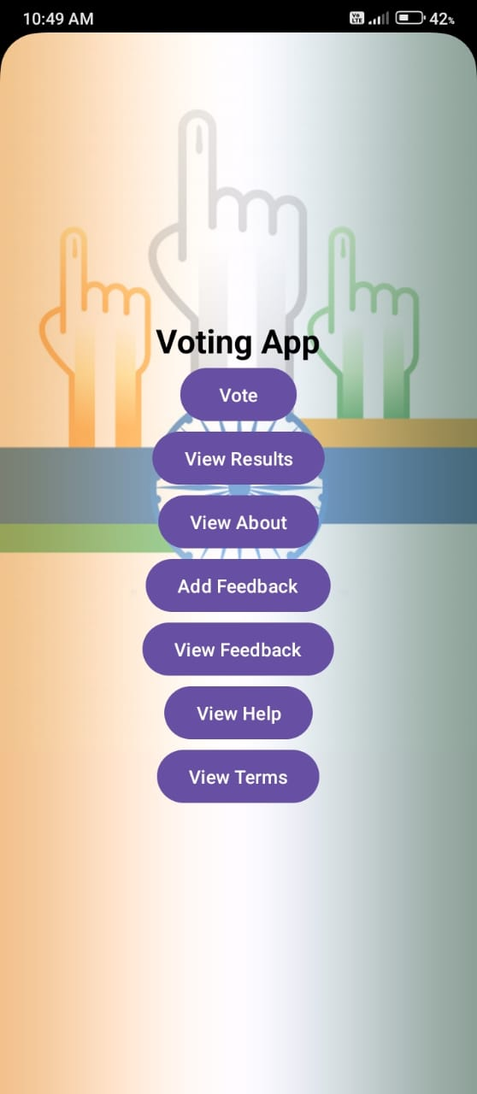

* **Vote Page**.

**Application of your Project**

1. User Registration and Authentication

2. Voting Process

3. Viewing Election Results

4. Feedback

5. Terms and Information

**Advantages and Disadvantages of Project**

* **ADVANTAGES OF VOTING SYSTEM:**

1. **Accessibility**

* Widespread Use: Android devices are widely used, allowing more people to participate in voting easily.
* Convenience: Users can vote from anywhere at any time, increasing participation rates.

1. **Real-time Feedback**

* Instant Results: Users can see results immediately after voting, which can enhance engagement.
* Dynamic Updates: Results can be updated in real time, keeping users informed.

1. **User Engagement**

* Interactive Features: Polls and voting can include interactive elements, encouraging users to engage more with the app.

1. **Security and Privacy**

* Secure Authentication: Implementing secure login systems (like biometrics or two-factor authentication) can enhance voter security.

1. **Improved User Experience**

* Intuitive Interfaces: Mobile apps can provide a more user-friendly experience than traditional voting methods.
* **DISADVANTAGES OF VOTING SYSTEM:**

1. **Security Risks**

* Hacking Vulnerabilities: Digital voting systems can be susceptible to cyberattacks, which can compromise the integrity of the voting process.
* Data Breaches: Personal information could be exposed if proper security measures are not in place.

1. **Technical Issues**

* Reliability of Devices: Users may experience issues like device malfunctions, connectivity problems, or software bugs that prevent them from voting.
* System Overloads: High traffic during voting periods could lead to server crashes or slowdowns.

1. **Fraud Potential**

* Duplicate Voting: Without strict controls, users could potentially vote multiple times, undermining the election's integrity.

1. **User Experience Challenges**

* User Engagement: If the voting process is too complicated or time-consuming, users may opt out**.**

**References**

* <https://www.geeksforgeeks.org/android-tutorial/>
* https://source.android.com/
* https://www.sqlite.org/c3ref/open.html